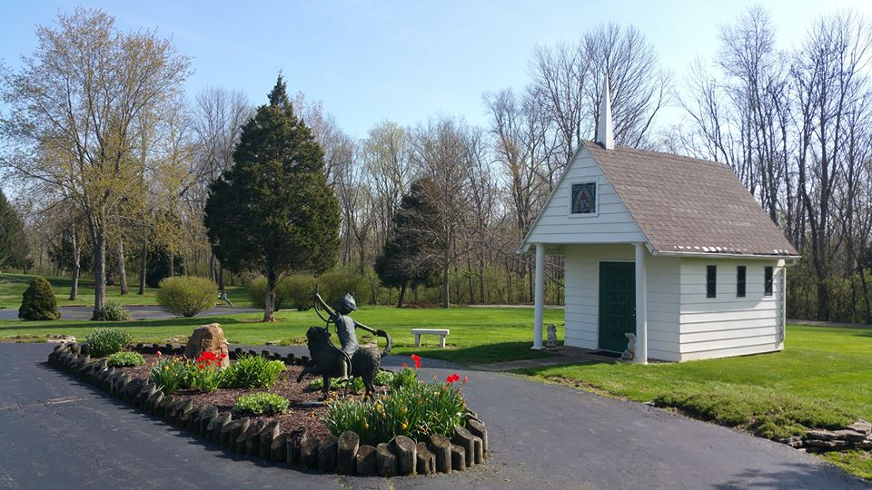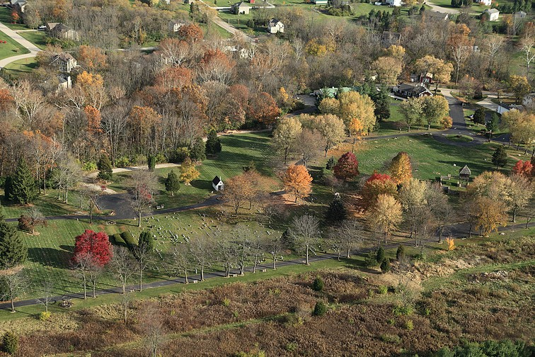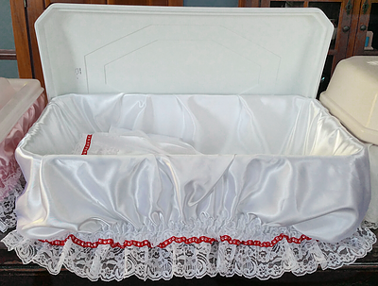

Office Hours

9:00 AM- 5:00 PM Monday-Friday

9:00 AM-2:00 PM Saturdays

Closed Sundays

Emergencies are handled as efficiently and promptly as permitted by the circumstances of the loss. Special services, such as calling for the deceased pet at home or at the veterinarian office, are available.

Please leave a message for the Pines staff and we will return your phone call as soon as possible. Please allow us 24 hours to respond if calling after hours.

 Deceased pets are brought to the Pines by their owners, or may be called for at home or veterinarian offices, All pets are properly identified and held in a refrigerated holding vault until the appointed day of cremation or burial. A special crematory is located on the cemetery grounds, and properly trained personnel perform all cremations. When cremation is completed, each pet’s cremains are carefully gathered and placed into labeled containers.

Dedicated to Preserving

The Memory of All

Beloved Pets since 1966

764 Riley Wills Rd

Lebanon, Ohio 45036

*Tel:* 513-932-2270 Lebanon

*Tel:* 937-228-6768 Dayton

*Tel:* 513-579-8250 Cincinnati

[PinesPetCemetery@centurylink.net](mailto:PinesPetCemetery@centurylink.net)

www.PinesPet.com

Pines Pet Cemetery

&

Cremation Center

## Procedure

***Inurnment*:**There is wide variety of urns available from a simple, modestly priced container to deluxe, engraved bronze urn. The urn may be kept at home along with the pet's other mementos or can be formally interred.

***Scattering*:**Cremains can be scattered in a place that was special for the pet or the family. Scattering is also available at the Pines. Cremation is simply the hastening of natural processes by a clean, sanitary, and entirely modern method, which is quickly effected by a clean, intense, flame that returns the body to its original elements. All that remain are the calcified bone fragments, and are called "cremains".

SPECIAL CARE IS TAKEN TO SEE THAT EACH PET RECEIVES THE INDIVIDUAL CARE AS SPECIFIED BY THE PET'S FAMILY. IT IS RECOMMENDED THAT ARRANGEMENTS FOR CREMATION BE MADE DIRECTLY WITH THE PINES.

             *Cremation price is based off pet weight*

**Private Burial:** Special boxes that are carefully sealed are available for burial either at home or at the cemetery. A burial plot will be selected, along with other desired amenities. Pet owners may choose exactly the services they wish for their pets, keeping in mind their budget and personal preferences. Later when the pet must leave you, a simple phone call is all that is needed. A member of our staff will take over, and a burial time will be scheduled. You may chose whether or not you want to be present for a final good-bye.

## **Country Burial:** Pines Pet Cemetery and Cremation Center provides for a more humane, while still affordable, choice for burial. The "Country Burial" is a common burial, one in which the remains of your pet is placed in the same burial with those of other pets and then covered with earth. We want to invite all pet owners to visit the park and consider us for the final resting place of your beloved pet.

We assure you that your pet's remains will be cared for with dignity by a dedicated staff of pet lovers who understands your special bond with your pet. Special care is taken to ensure that each pet receives the individual care specified by the pet's family. Options for final disposition of the cremains include placement in an urn, ground burial at the Pines or your home, scattering in the Chapel Gardens at the Pines or some other place of importance to you and your pet. Here at the Pines we do individual cremations with a turnaround time of 24-48 hours.

Cremation

Burial